CEL 62, CSS, Spring 2021

Lab 6: Firewall & Intrusion Detection System

**Objectives**

In this lab students will explore the Snort Intrusion Detection Systems. The students will study Snort IDS, a signature based intrusion detection system used to detect network attacks. Snort can also be used as a simple packet logger. For the purpose of this lab the students will use snort as a packet sniffer and write their own IDS rules.

**Software Reequirment**

All required files are packed and configured in the provided virtual machine image.

-The VMWare Software - <http://apps.eng.wayne.edu/MPStudents/Dreamspark.aspx>

- The ubantu 14.04 or Ubantu Long Term Support (LTS) versionor Kali linux image

- The ubantu 14.04 or Ubuntu 14.04 Long Term Support (LTS) Version

- Snort: A signature-based Intrusion Detection System <https://www.snort.org/#get-started>

**Implementation**

**Starting the Lab 1 Virtual Machine**

In this lab, we use Ubuntu as our VM image.

Login the Ubuntu image with username and password

**Installing Snort into the Operating System**

To install the latest version of the snort, you can follow the installation instruction from the snort website. Note that installation instructions are vary from OSes. The instruction below shows how to install snort from its source code on Linux.

You can find more information here:

<https://www.snort.org/#get-started>

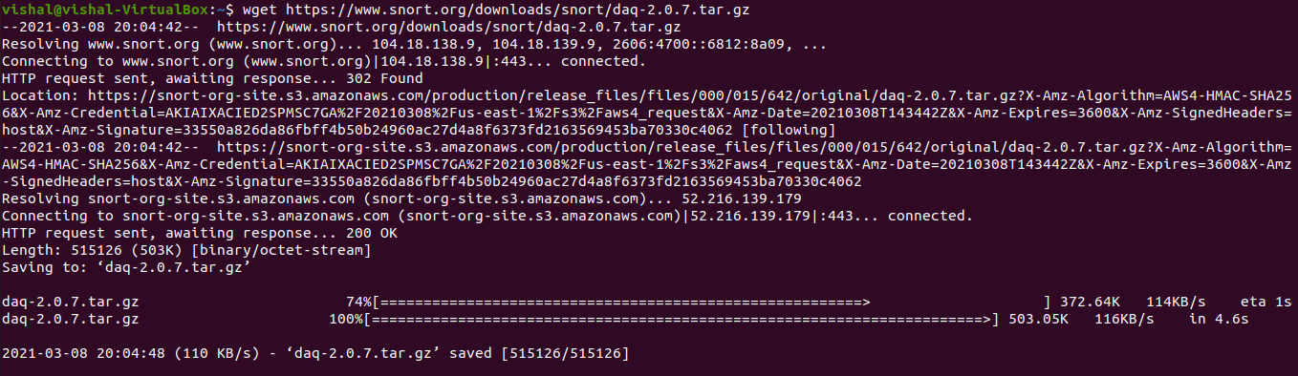

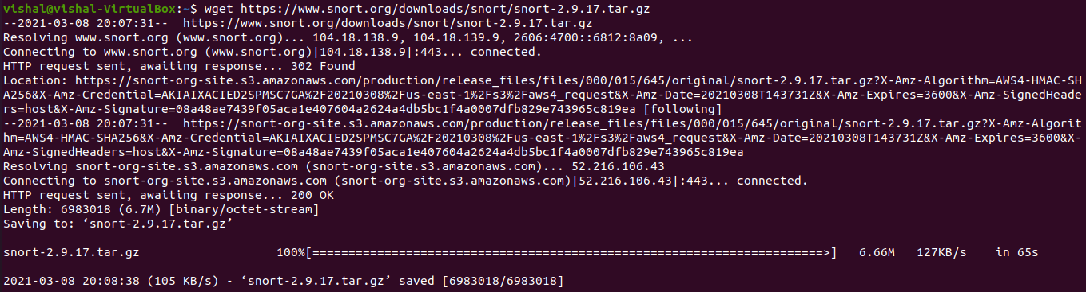

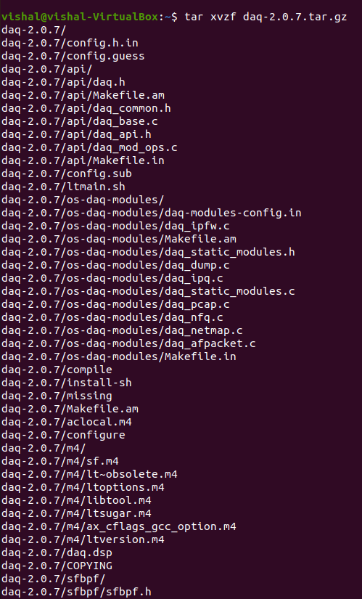



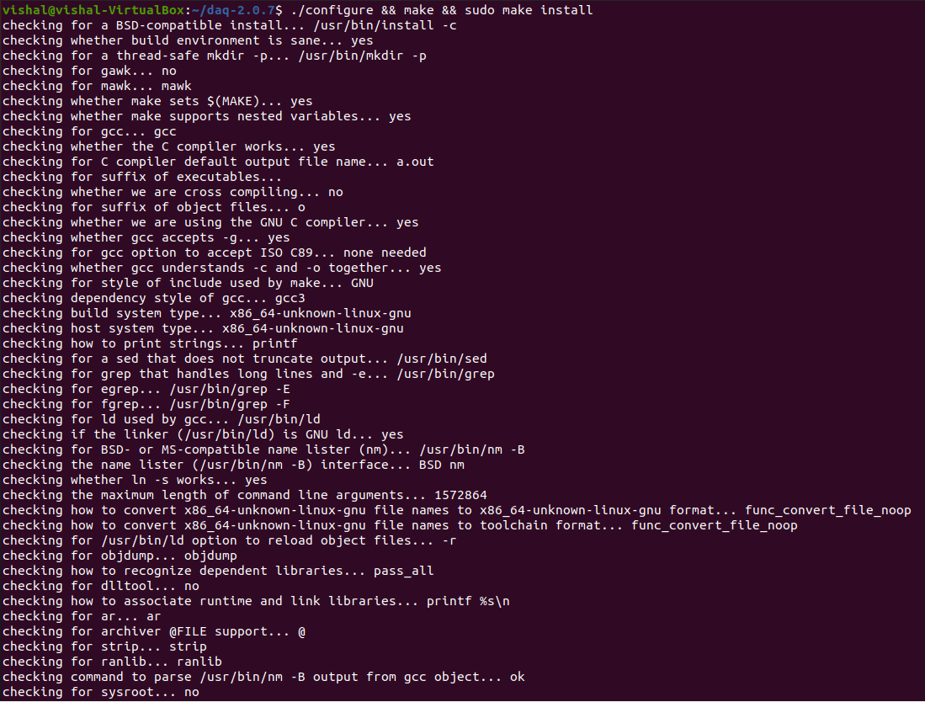

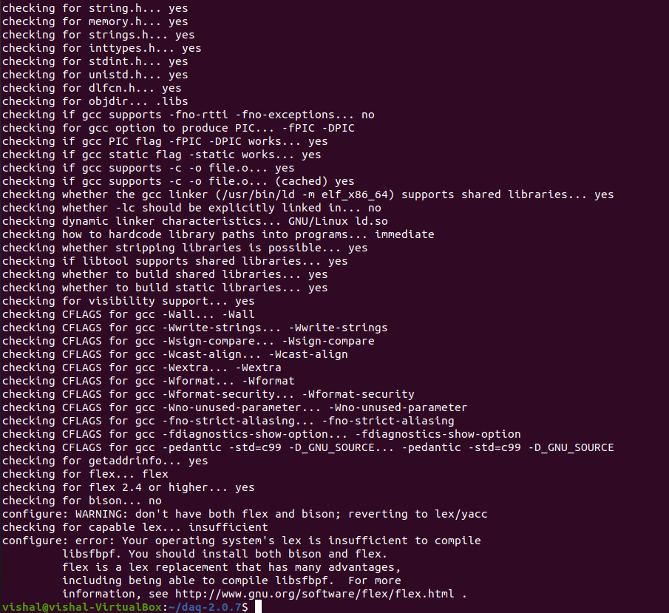

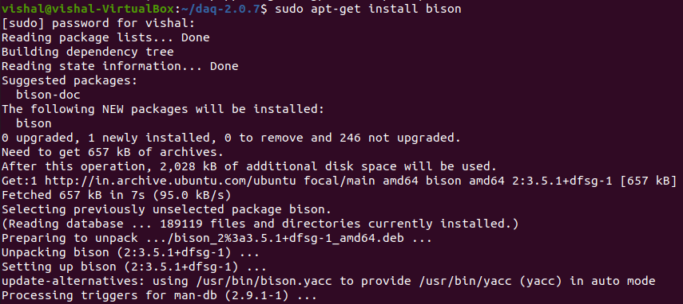

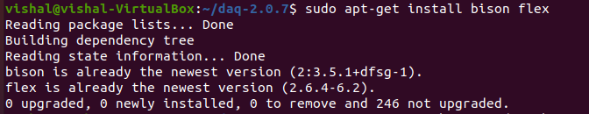

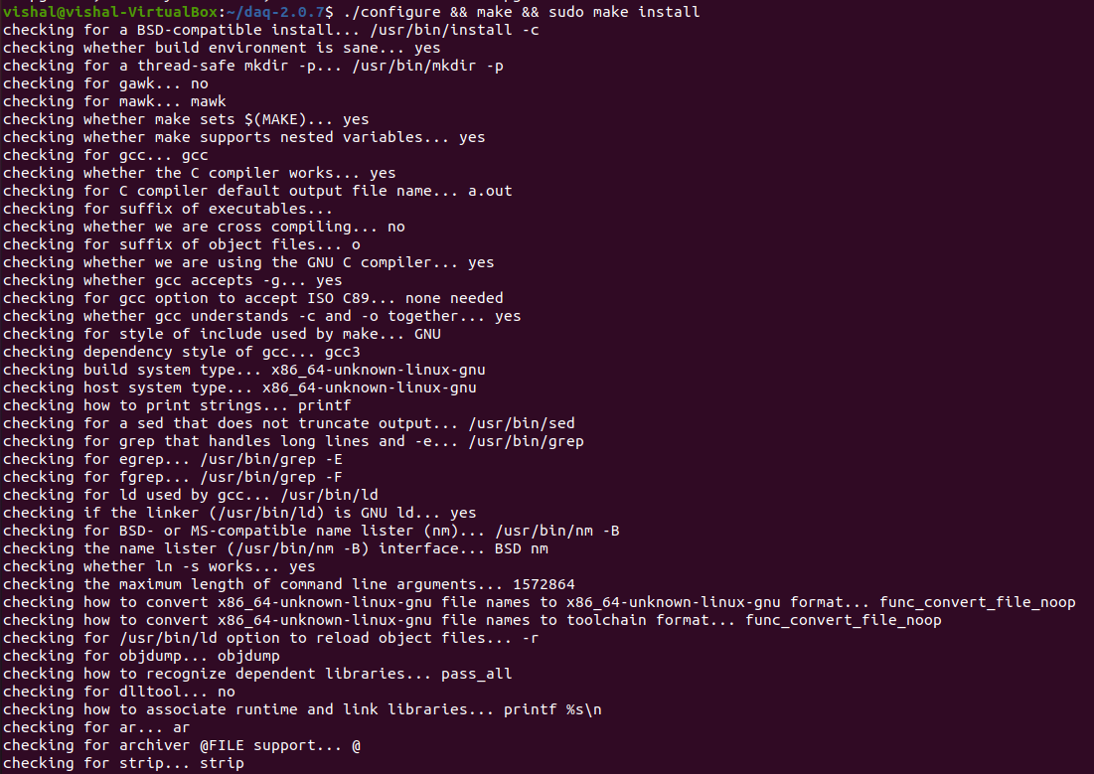

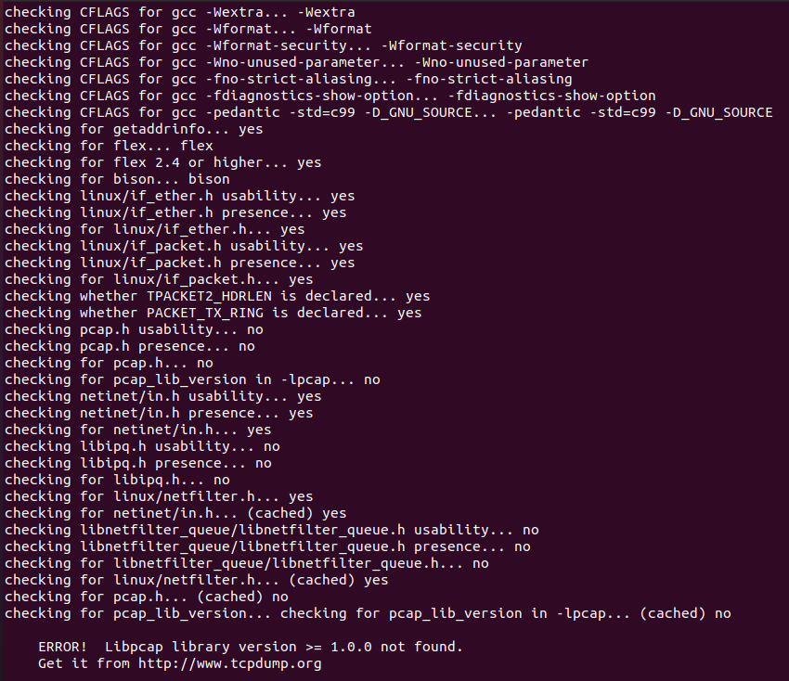

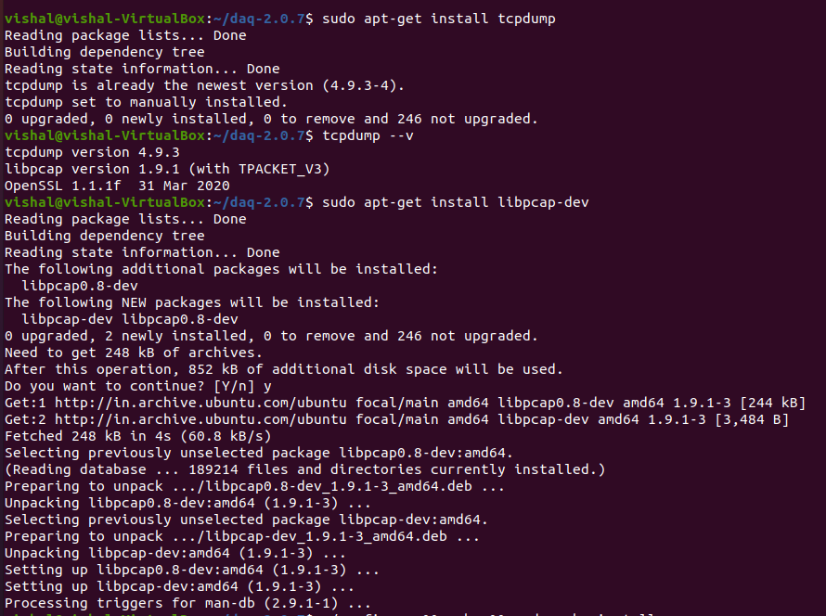

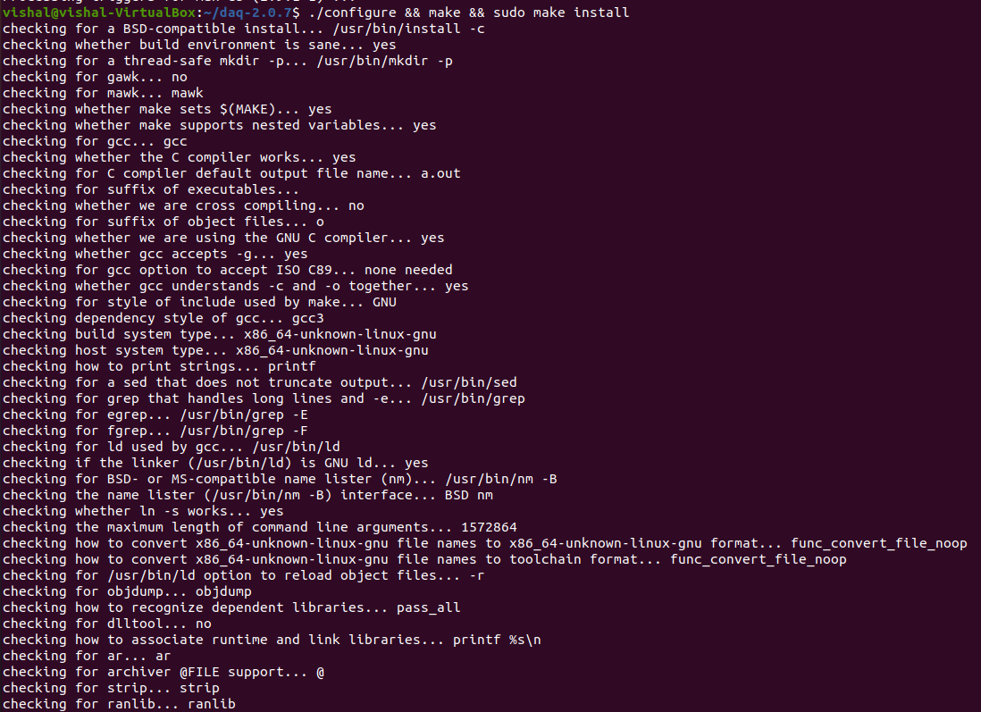

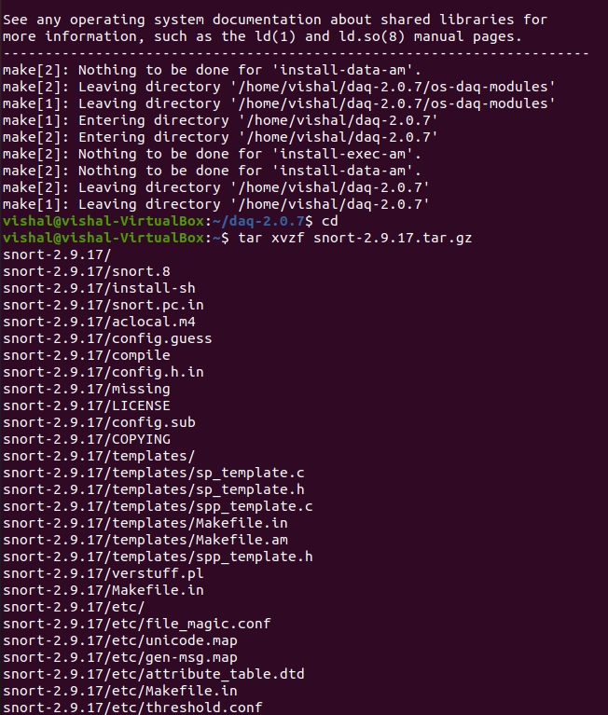

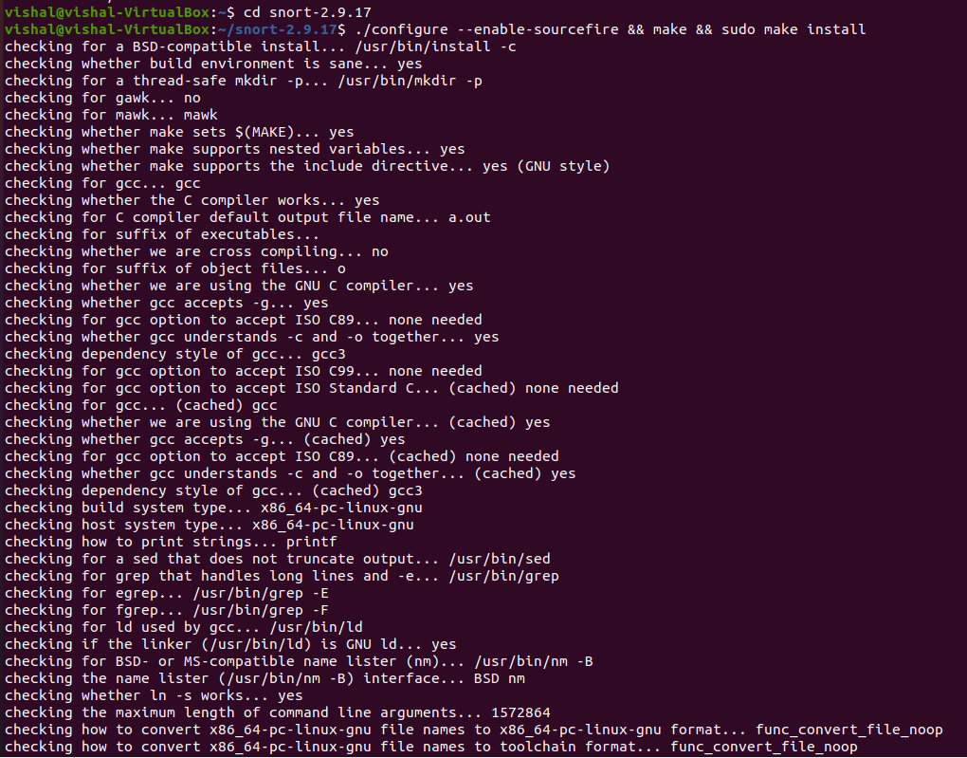

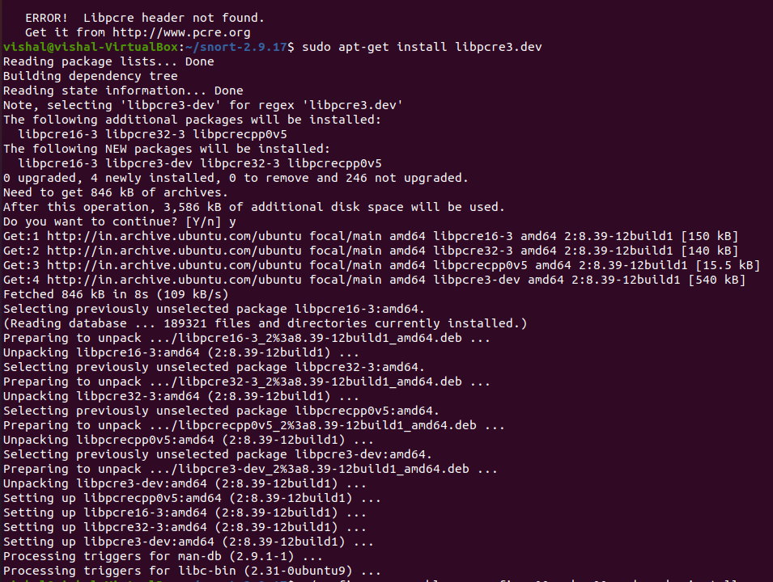

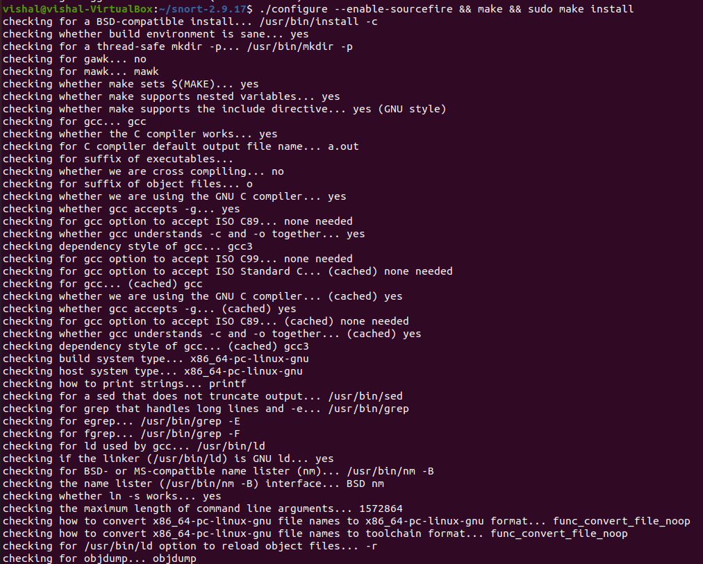

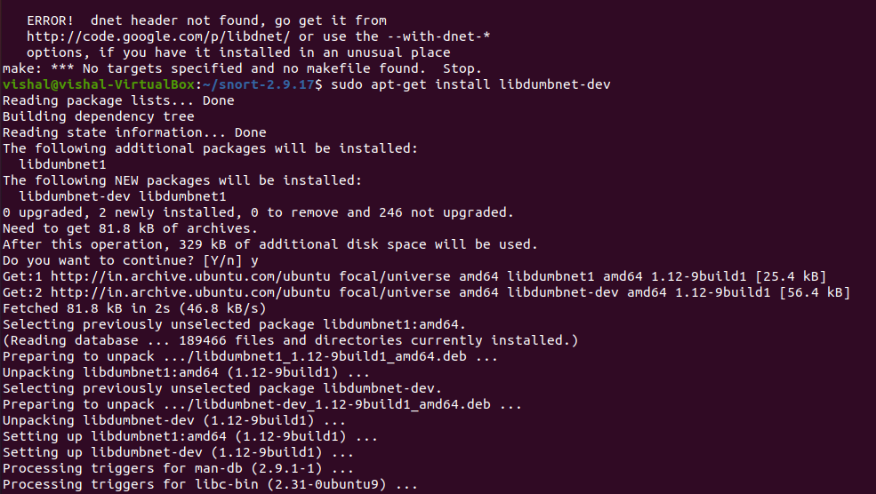

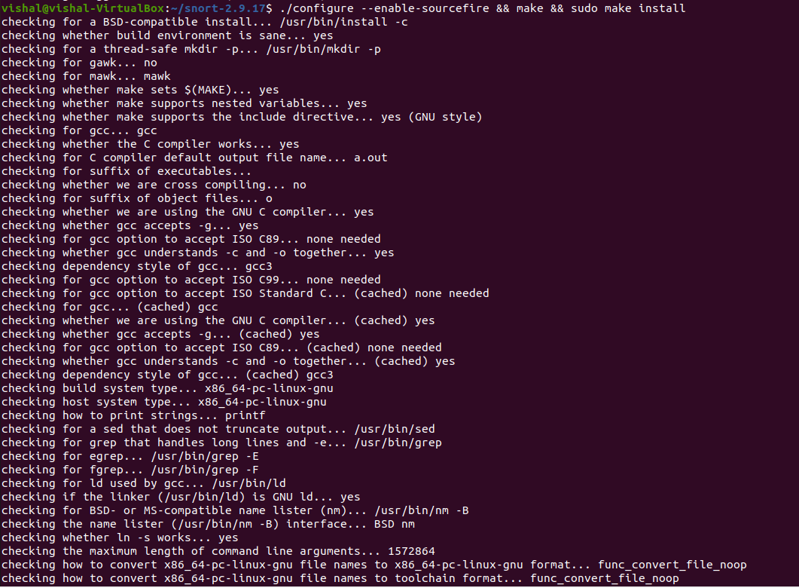

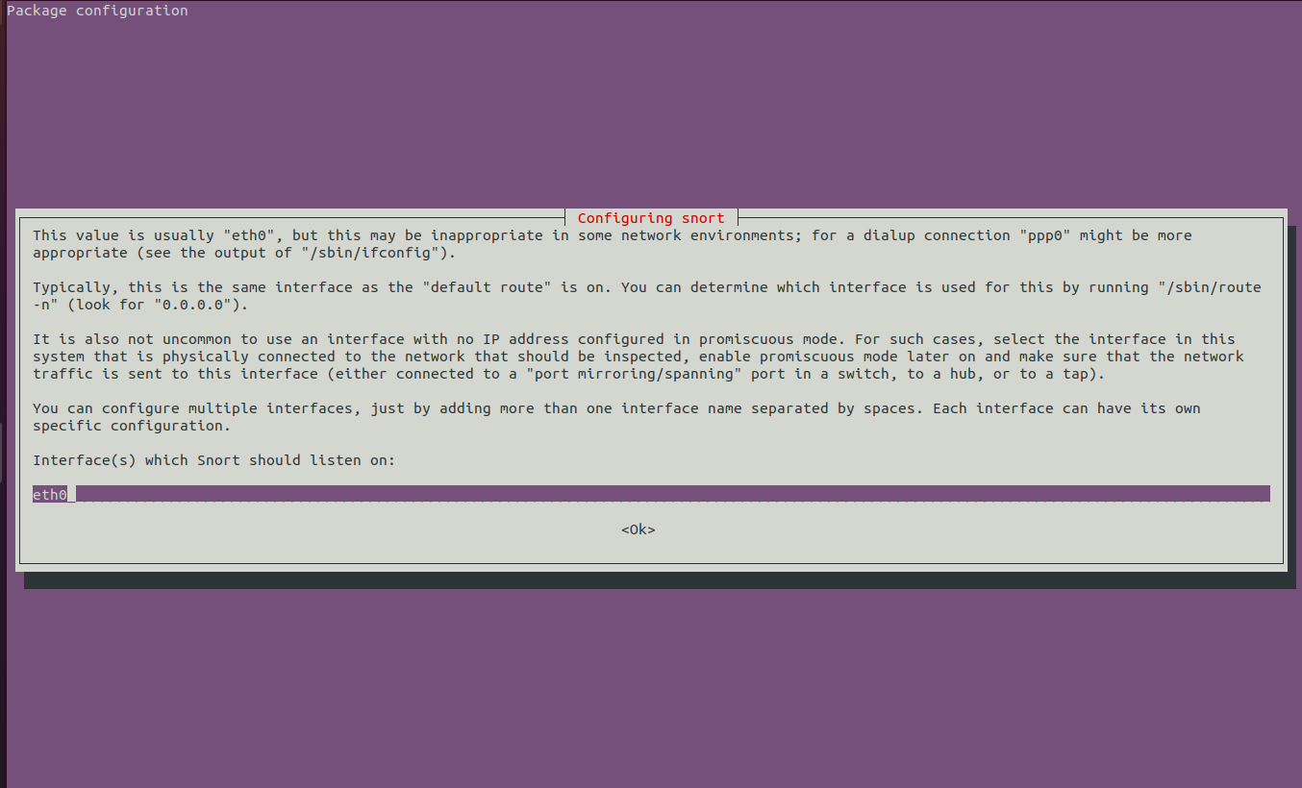

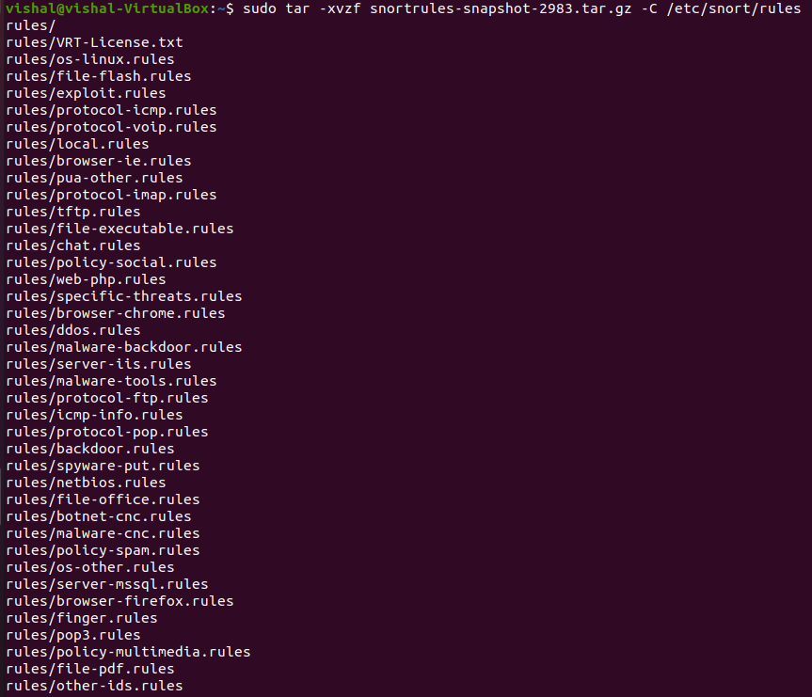

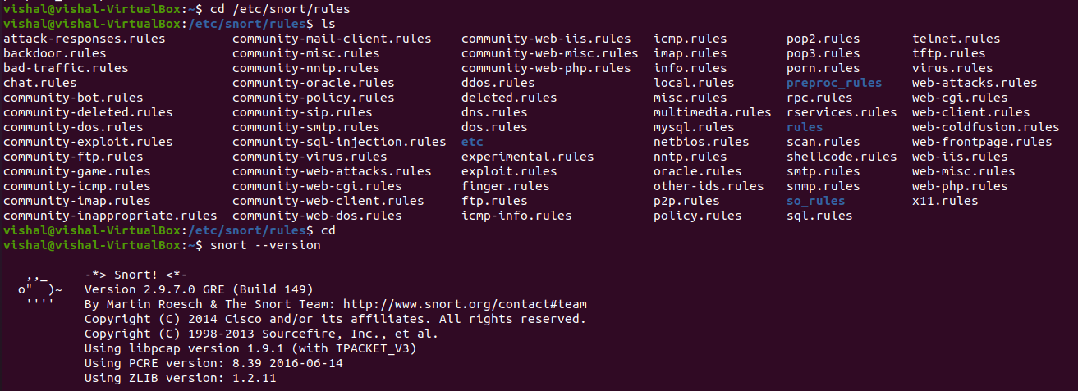

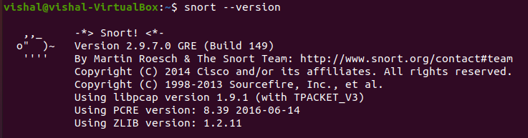

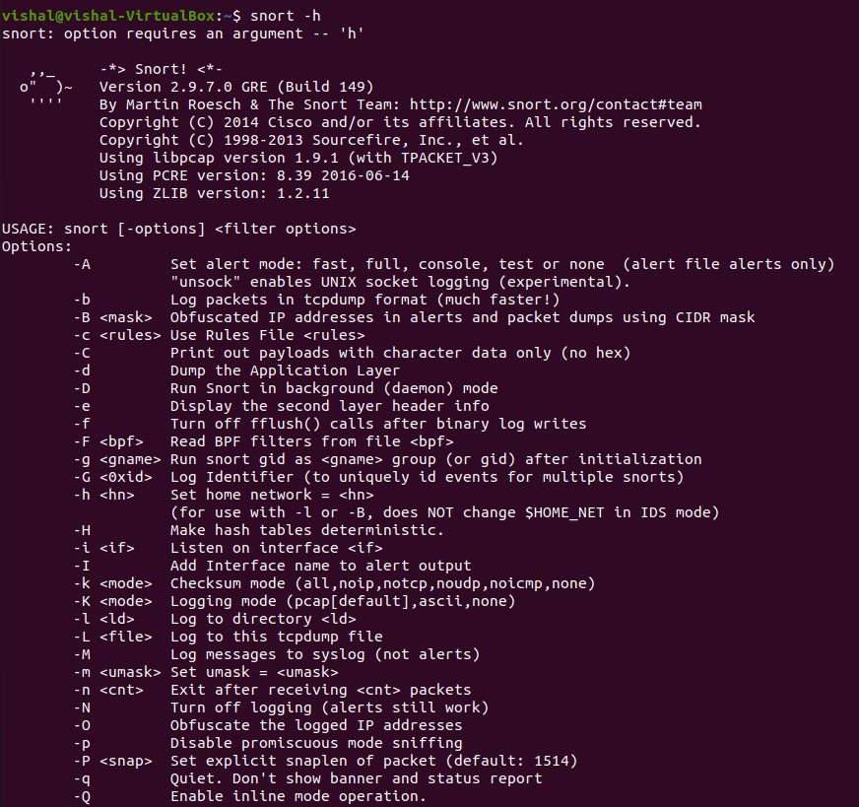

While you install the snort, you system may miss some libraries. You need to install the required libraries, too.

Snort is software created by Martin Roesch, which is widely used as Intrusion Prevention System [IPS] and Intrusion Detection System [IDS] in the network. It is separated into the five most important mechanisms for instance: Detection engine, Logging, and alerting system, a Packet decoder, Preprocessor, and Output modules.

The program is quite famous to carry out real-time traffic analysis, also used to detect query or attacks, packet logging on Internet Protocol networks, to detect malicious activity, denial of service attacks and port scans by monitoring network traffic, buffer overflows, server message block probes, and stealth port scans.

Snort can be configured in three main modes:

Sniffer mode: it will observe network packets and present them on the console.

Packet logger mode: it will record packets to the disk.

Intrusion detection mode: the program will monitor network traffic and analyze it against a rule set defined by the user.

After that, the application will execute a precise action depend upon what has been identified.

**Configuring and Starting the Snort IDS**

After installing the Snort, we need to configure it. The configuration file of snort is stored at /etc/snort/snort.conf. The screenshot below shows the commands to configure the Snort. You need to switch to root to gain the permission to read the snort configurations file.

After configuring the Snort, you need to start the Snort. You can simply type the following command to start the service.

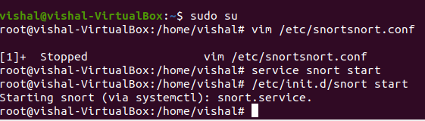

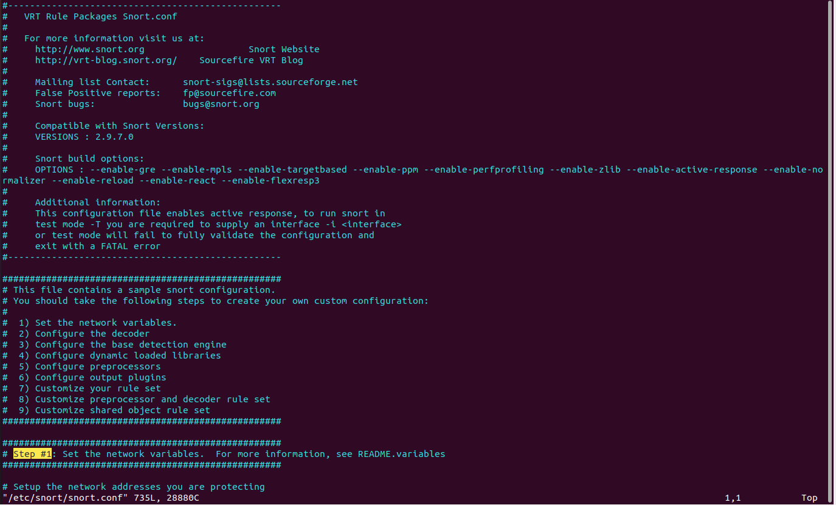

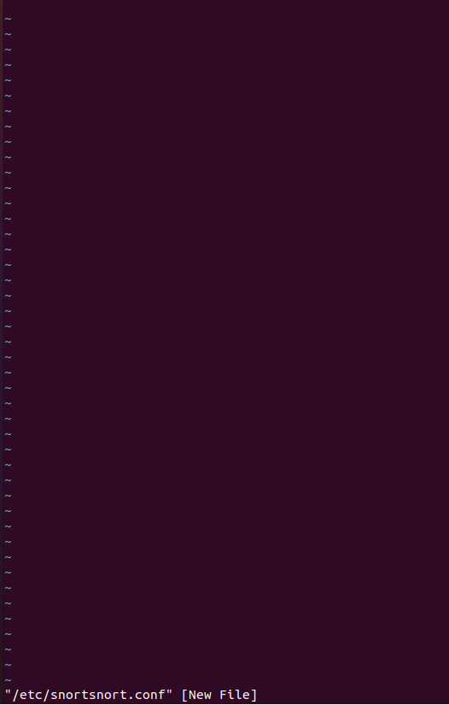

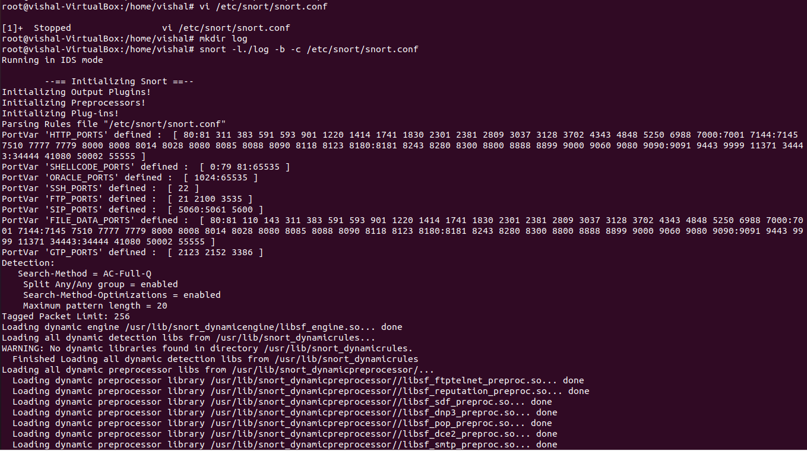

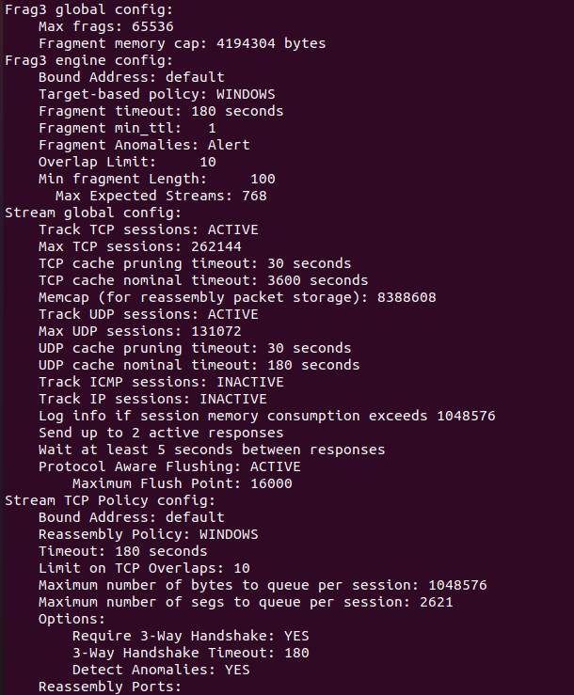

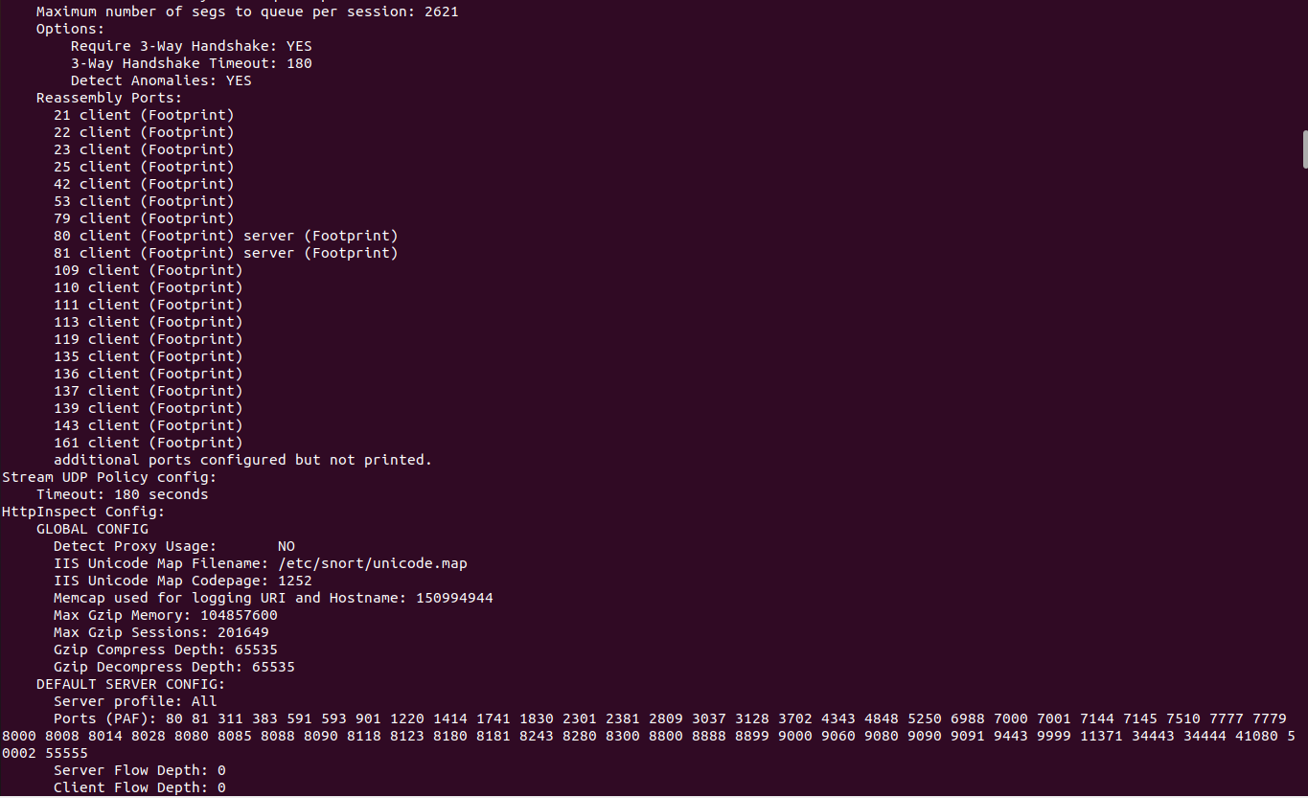

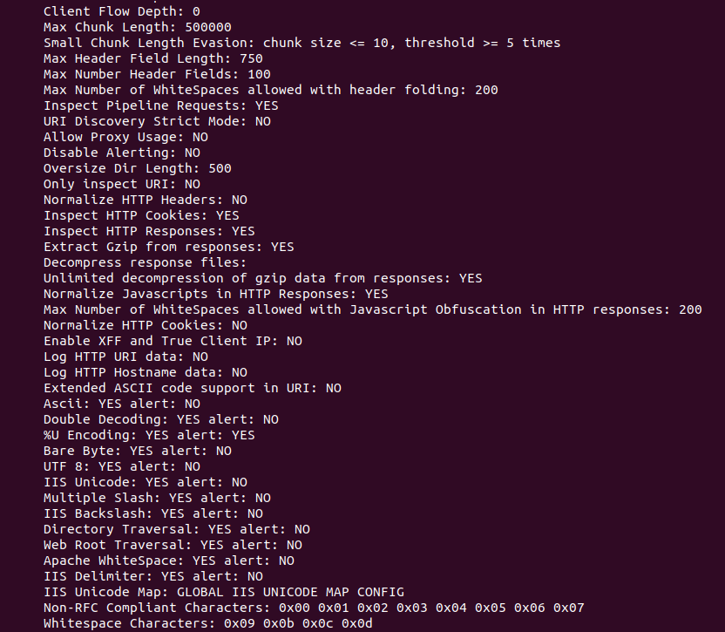

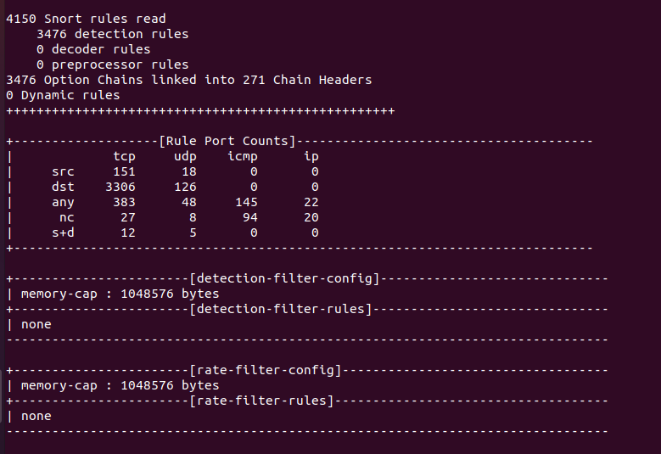

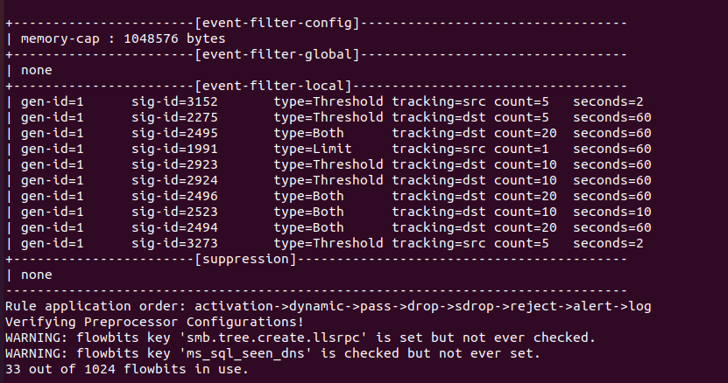

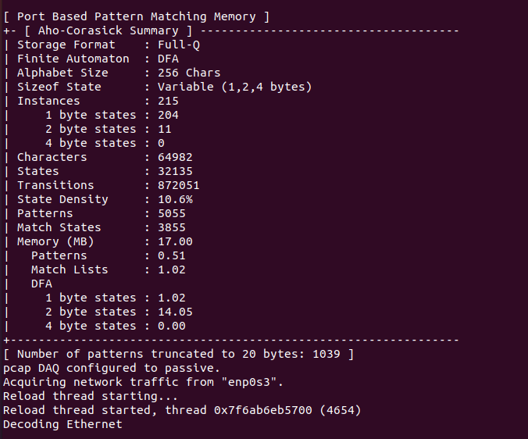

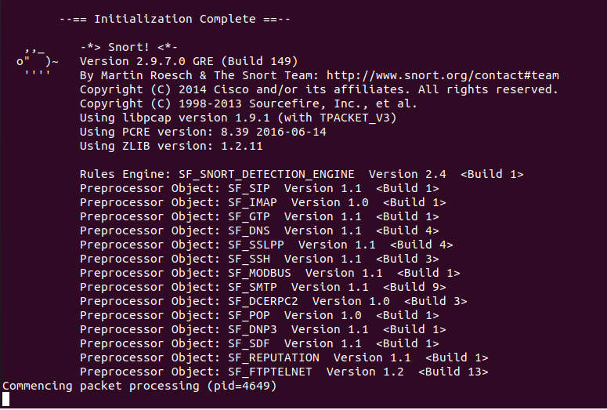

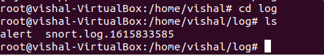

$ service snort start

or

$ /etc/init.d/

snort start

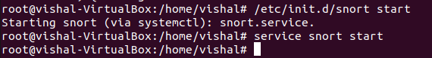

**Snort Rules**

Snort is a signature-based IDS, and it defines rules to detect the intrusions. All rules of Snort are stored under /etc/snort/rules directory. The screenshot below shows the files that contain rules of Snort.

$ ls /etc/snort/rules

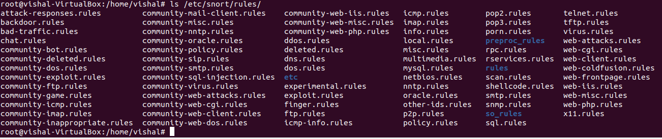

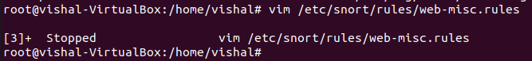

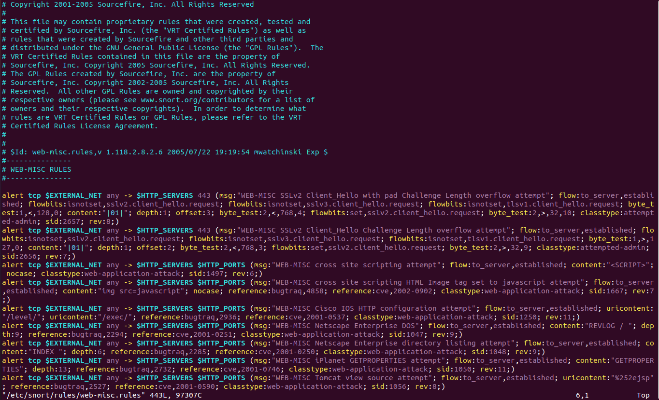

**Writing and Adding a Snort Rule**

Next, we are going to add a simple snort rule. You should add your own rules at /etc/snort/rules/local.rules. Add the following line into the local.rules file

alert icmp any any -> any any (msg:"ICMP Packet found"; sid:1000001; rev:1;)

Basically, this rule defines that an alert will be logged if an ICMP packet is found. The ICMP packet could be from any IP address and the rule ID is 1000001. e.g. Make sure to pick a SID greater 1000000 for your own rules.

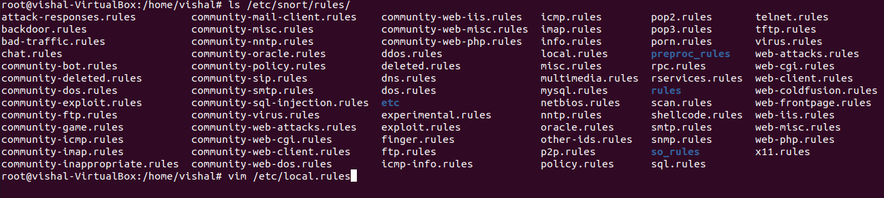

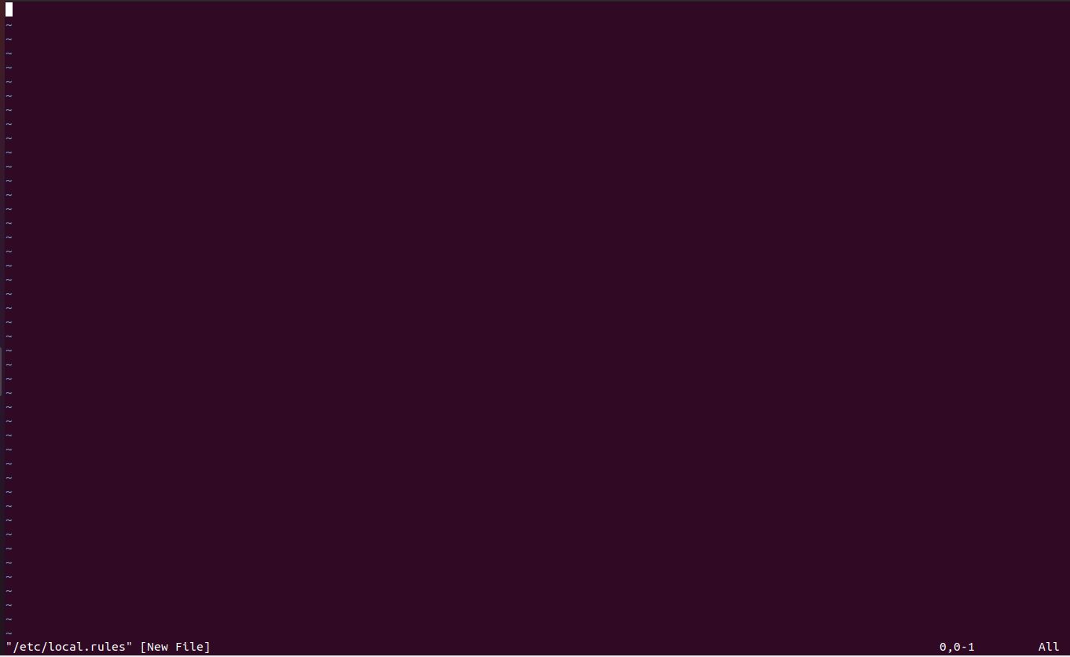



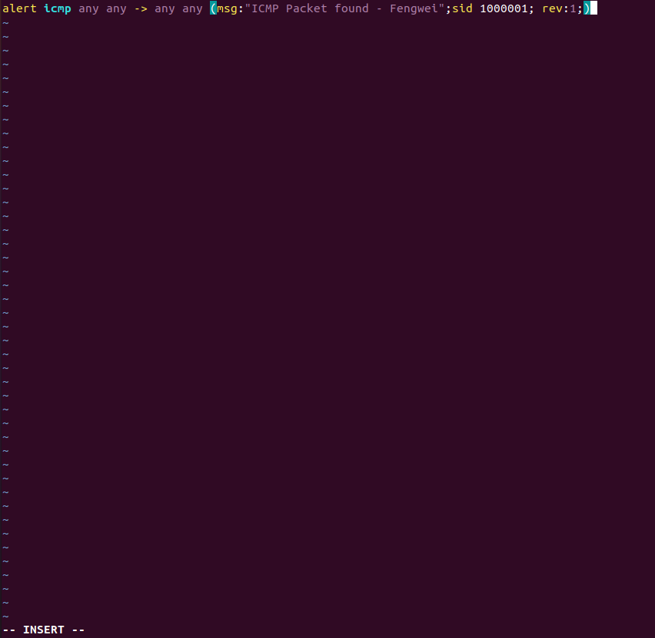

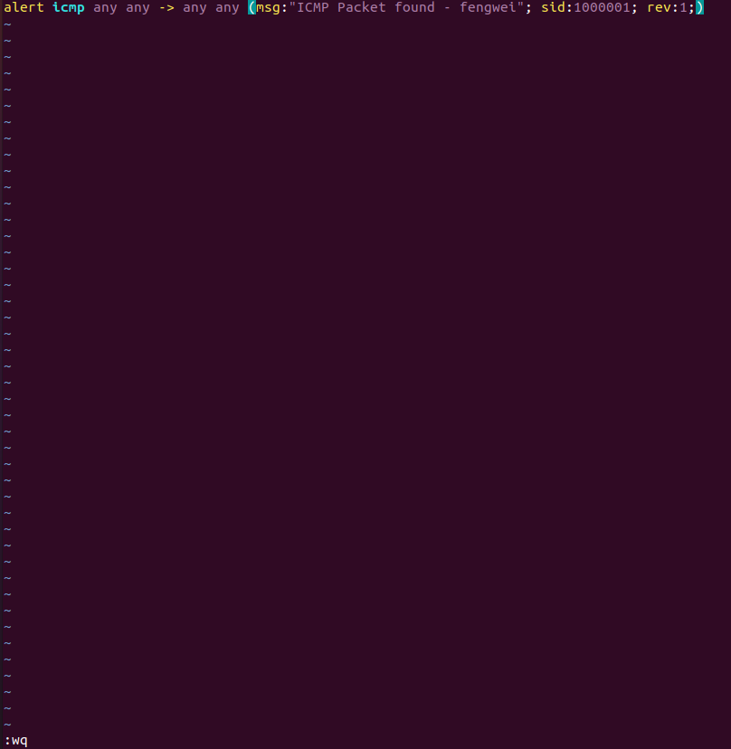

To make the rule become effective, you need to restart the snort service by typing the following command.

$ service snort restart

or

$ /etc/init.d/snort restart

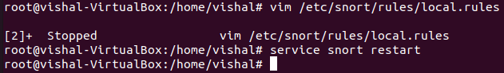

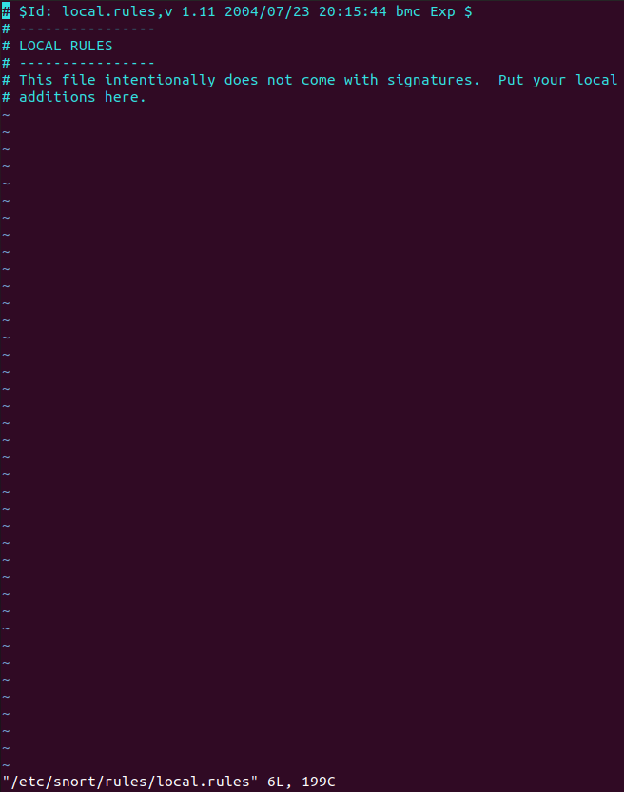

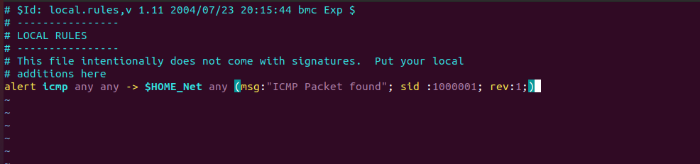



**Triggering an Alert for the New Rule**

To trigger an alert for the new rule, you only need to send an ICMP message to the VM image where snort runs. First, you need to find the IP address of the VM by typing the following command.

$ ifconfig

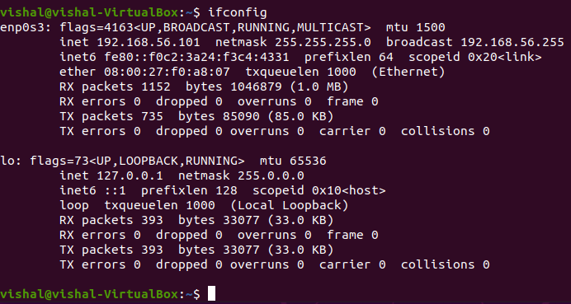

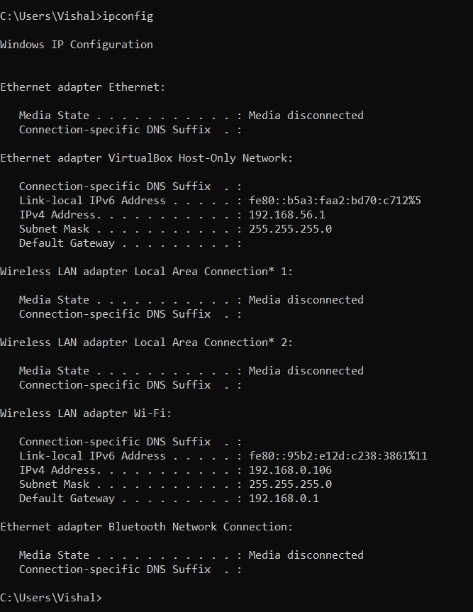

For instance, the screenshot shows the execution result on my VM image, and the IP address is e.g. 172.16.108.242

After you have a terminal, you can just type the following command to send ping messages to the VM.

$ ping 172.16.108.242

After you send the ping messages, the alerts should be triggered and you can find the log messages in /var/log/snort/snort.log. However, the snort.log file will be binary format. You need to use a tool, called u2spewfoo, to read it. Observer terminal on screen with log where you can see that the SID is 1000001, and the alerts are generated by the ICMP messages.

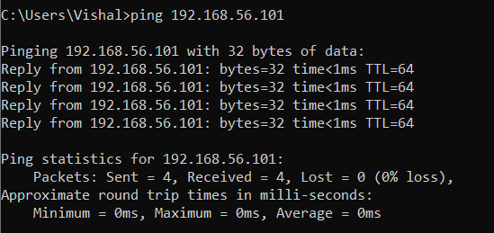

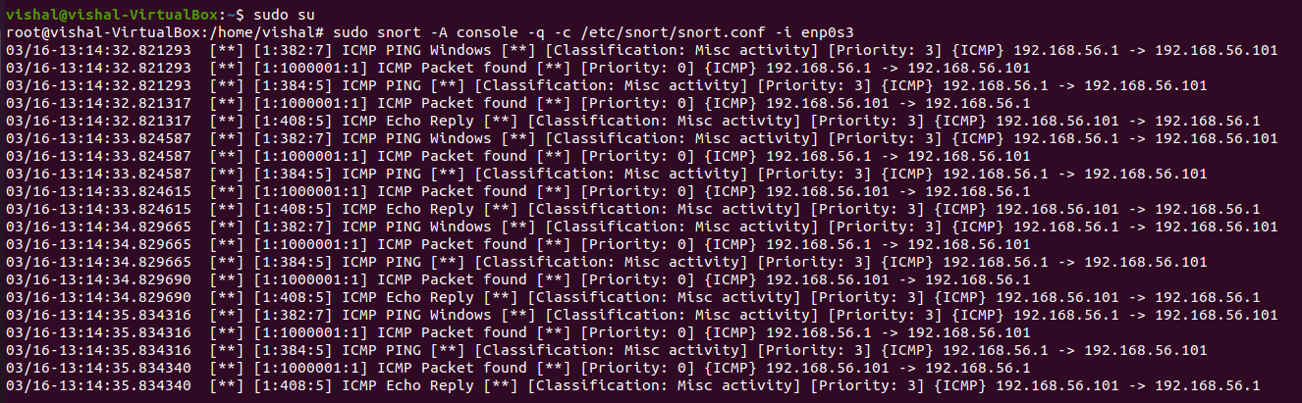

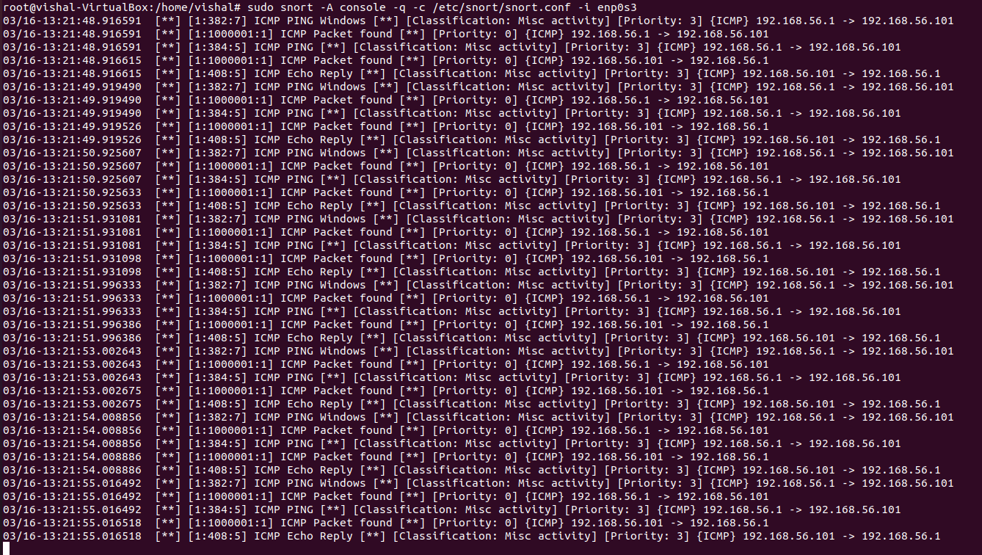

**Assignments for Lab 1**

1.Read the lab instructions above and finish all the tasks.

2.Answer the questions and justify your answers. Simple yes or no answer will not get any credits.

a. What is a zero-day attack?

A zero-day vulnerability refers to a software vulnerability unknown to the manufacturer which if it comes to the notice of hackers can be successfully exploited by them. In other words, it is a security hole in a software which is discovered and exploited by the hacking community even before the developers (or the vendors) of the software become aware of it.

This type of security threat can prove extremely fatal since the software developers themselves are not aware of the security vulnerability being exploited and therefore it could be weeks or months before the [appropriate patch](https://one.comodo.com/patch-management/open-source-patch-management.php) or fix is released to remedy the security vulnerability. Enough time for the hacking community to wreak havoc.

It gets its name as ‘**zero-day**‘ vulnerability because the security vulnerability is ‘yet-to-be-discovered’ by the software manufacturer or vendor. (To be more precise, it’s been ‘zero days’ since the security vulnerability was discovered. Therefore ‘zero-day vulnerability!’).

**How to recognize it**

Unfortunately recognizing [zero-day exploits](https://securebox.comodo.com/pos-system/zero-day-attack/) is not an easy task. But with the right kind of security software, you’ll be better equipped to handle such attacks. Therefore, let’s take a look at the factors you should focus on in order to successfully counter these zero-day exploits.

**Here’s a typical lifecycle of an attack utilizing zero days to compromise devices:**

1. A vulnerability or new attack vector is discovered by a malware author.
2. The capability is weaponized and proven to work
3. The zero day is kept secret and utilized by cyber criminals.
4. The vulnerability is discovered by defenders.
5. The OS vendor or application vendor deliver a patch.
6. The zero day is no longer a zero day.

b. Can Snort catch zero-day network attacks? If not, why not? If yes, how?

No, snort cannot catch zero-day attack. As snort checks with the predefined rules for prevention of attacks and zero-day attacks are unknown to the developers, so without the rules it cannot be prevented.

c. Given a network that has 1 million connections daily where 0.1% (not 10%) are attacks. If the IDS has a true positive rate of 95%,and the probability thatan alarm is an attack is 95%. What is the false alarm rate?

No of attacks = 0.1% of 1000000 = 1000 attacks

No of benign events = 99.9% of 1000000 = 999000 events

IDS has a true positive rate of 95% means that out of 1000 attacks, only 950 will set of alarms.

Therefore, Number of true alarms = 950 alarms

Since 95% of the total alarms are attacks,

No of total alarms = (100 * 950) / 95 = 1000 alarms

No of false alarms = 1000 – 950 = 50 alarms.

Therefore, False Alarm Rate

= (Number of false alarms / Total Benign Events) * 100

= (50 / 999000) * 100

**= 0.005 %**

3.Write and add another snort rule and show me you trigger it.

a. The rule you added (from the rules file)



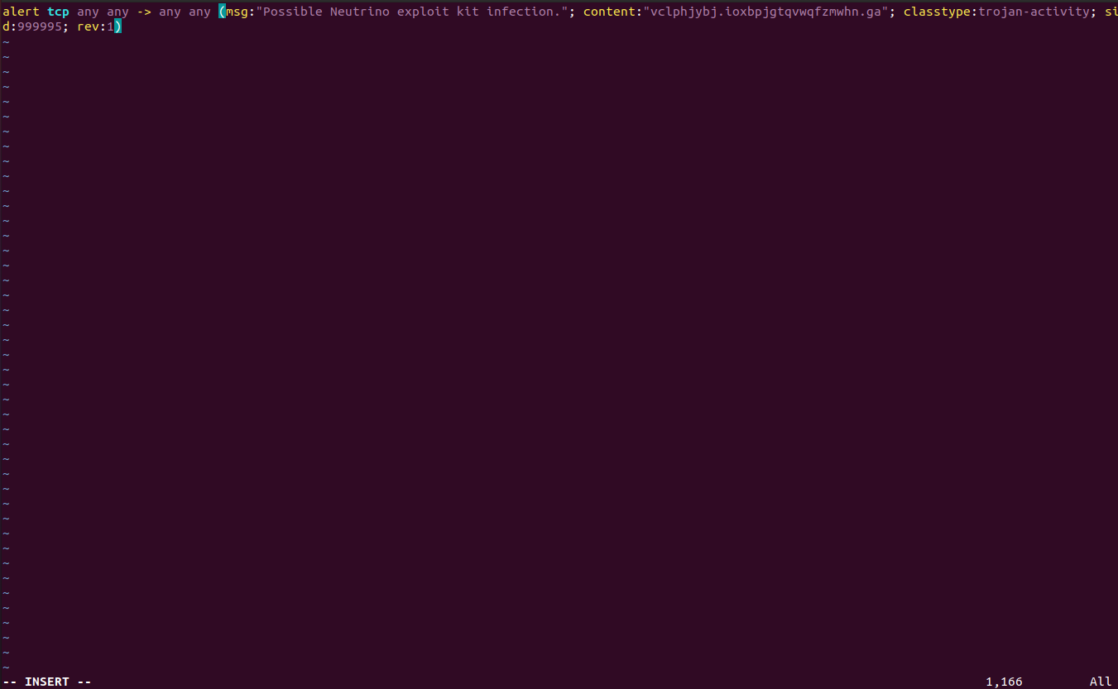

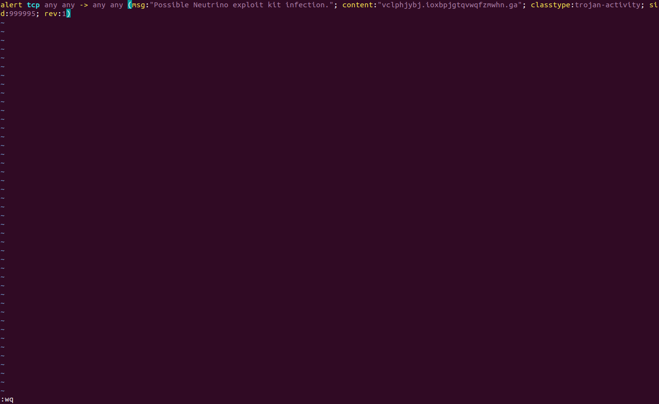



b. A description of how you triggered the alertc.The alert itself from the log file (after converting it to readable text)

Extra Credit (10pt):Write a rule that will fire when you browse to any site from the machine Snort is running on; it should look for any outbound TCP request to the site you have considered and alert on it.





**Conclusion:**

1. Snort has the capability to detect unusual incoming packet traffic in a network. To analyze intruder or malicious activity, it is foremost in understanding the malicious pattern. The malicious pattern is a basic information to generate Snort rules.
2. Snort detection is based on the Snort rules, which matched with the Snort rules in the database. Snort rules is a simple rule and easy to understand because most of Snort rules write on single line and describes about basic structure of rule.